ITEM DETAILS
Name of Item | Functionalist House
Other Name/s  Former Name/s | 57 Hardy Street, Dover Heights
Item type | Built
Item group | Residential Buildings (private)
Item category | House
Area, Group, or Collection Name | Unknown
Street number | 57
Street name | Hardy Street
Suburb/town | Dover Heights |  |  |  |  | Postcode |  |  | 2024
Local Government Area/s | Waverley
Property description | Lot 23 DP 11822
Location - Lat/long | Latitude | -33.877215 |  | Longitude | 151.278121
Location - AMG (if no street address) | Zone |  |  | Easting |  |  |  | Northing
Owner | Private
Current use | Residential
Former Use | Residential
Statement of significance | 57 Hardy Street, Dover Heights (1939) is a fine and intact example of an Inter-War Functionalist Streamlined Moderne-style residence that reflects the Inter-War period development of Dover Heights in response to the increased car ownership.  It represents the subdivision and residential development of Dover Heights in the Inter-War period, reflecting the 1920s-1930s development boom, a prominent period of economic prosperity and speculative development in Waverley.  The building demonstrates the pattern of change in Inter-War residences to incorporate the garage, reflecting the growth of private vehicle ownership and the lack of public transport in Dover Heights.  The building has historic association with architect F.A. Leslie Allen, a well-known Waverley architect, and the Sheedy family.
Level of Significance | National |  | State |  |  |  | Local

DESCRIPTION
Designer | Waverly architect F.A. Leslie Allen
Builder/ maker

Physical Description | 57 Hardy Street, Dover Heights is a one and a half-storey freestanding residence that dates from the late Inter-War period (1939), within the key period of significance of the 1923 Dover Heights subdivision. The building displays features of the Inter-War Functionalist (Streamlined Moderne) style including simple geometric shapes, projecting semicircular wing, face-brick wall finishes, corner windows, and horizontal emphasis - eaves, basecourse, bands of windows.  The building is setback 12 metres from the street on an average site approximately 12 metres wide, that reflects the original subdivision pattern in a suburban setting that has partially lost its historic context.  The site has a fence of sandstone block approximately 0.5 metres high, which compliments the setting of the place and a garage on the street alignment which dates from the Inter-War period.  The site is informally landscaped, and features a sandstone outcrop, a path, steps, lawn, a rockery and provides an appropriate setting for the building. The building is in excellent condition and is highly intact.  Elements impacting upon the integrity of the site include an early addition of an attic.
Physical condition  and  Archaeological potential | The building appears to be in excellent condition.
Construction years | Start year | 1939 | Finish year | 1939 | Circa
Modifications and dates | Later in 1939, plans to alter attic room and modification of the hipped roof over the semi-circular bay to a flat roof.  The garage is evident in 1939.

HISTORY
Historical notes | 57 Hardy Street, Dover Heights was part of Section N of the Dover Heights Estate, subdivided into large lots (132 feet wide x 313 feet long), offered for auction sale in March 1886. The land was resubdivided under DP11822 by J.B.Cramsie in 1923. Sidney Sheedy purchased the site in the 1920s . Designed by well-known Waverley architect F.G. Leslie Allen in 1938, for J.H. Sheedy. The plans were approved by Waverley Council in January 1939. Later in 1939, Sheedy submitted plans to alter the residence with an attic room and modification of the hipped roof over the semi-circular bay to a flat roof. These plans were also prepared by Leslie Allen. The house was constructed in 1939 and is evident in the 1943 aerial photograph. The garage is evident at this time (despite not being included on the 1938/9 plans). The house remained in the Sheedy family for 3 generations. David Sheedy (1938-2018) was a heritage architect, active in the National Trust of NSW and NSW State Rail Heritage Group . The David Sheedy Foundation offers funding and support to not-for-profit organisations or individuals to develop, maintain, preserve, conserve, and educate the community on historical items including architecture, engineering, cultural items and artefacts.

THEMES
National  historical theme | 4 Building settlements, towns and cities  8 Developing Australia’s Cultural Life  9 Marking the phases of life
State  historical theme | Towns, suburbs and villages  Land tenure  Accommodation  Domestic life  Persons
Local  historical theme | Traffic and Transport  Flats and Bungalows  Speculation and Subdivision

Assessment
A: Historical Significance | 57 Hardy Street, Dover Heights has historical significance at a local level as it demonstrates the 1923 resubdivision of the Dover Heights Estate by John Boyd Cramsie.  57 Hardy Street, Dover Heights has historical significance at a local level as it represents the subdivision and residential development of Dover Heights in the Inter-War period, reflecting the 1920s-1930s development boom, a prominent period of economic prosperity and speculative development in Waverley.  57 Hardy Street, Dover Heights has historical significance at a local level as it demonstrates the pattern of change in Inter-War residences to incorporate the garage, reflecting the growth of private vehicle ownership and the lack of public transport in Dover Heights.
B: Associative | 57 Hardy Street, Dover Heights has historical association significance at a local level as it is associated with architect F.A. Leslie Allen, a well-known Waverley architect, and the Sheedy family.  The house remained in the Sheedy family for 3 generations. David Sheedy was active in the National Trust of NSW and NSW State Rail Heritage Group.
C: Aesthetic significance | 57 Hardy Street, Dover Heights has aesthetic significance at a local level as it is a fine and intact example of a one and a half-storey freestanding Inter-War Functionalist Streamlined Moderne residence.  The building displays features of the Inter-War Functionalist Streamlined Moderne style including simple geometric shapes, projecting semi-circular wing, face-brick wall finishes, corner windows, and horizontal emphasis - eaves, basecourse, bands of windows.
D: Social significance | To date no social, cultural, and spiritual significance has been identified.
e) Technical/  Research significance | To date no technical significance has been identified.
f) Rarity | To date the research indicates 57 Hardy Street, Dover Heights is not rare.
g) Representative-ness | 57 Hardy Street, Dover Heights has representative significance at a local level as it is a fine and intact example of an Inter-War Functionalist Streamlined Moderne-style residence that reflects the Inter-War period development of Dover Heights in response to the increased car ownership.
Integrity | The building is highly intact.

HERITAGE LISTINGS
Heritage listing/s | Draft Waverley LEP 2012

INFORMATION SOURCES
Type | Author/Client | Title | Year | Repository
 | Waverley Council | Waverley Heritage Policy | 2007
 | Waverley Council | Waverley Heritage Study | 1993
 | Perumal Murphy Pty Ltd | Waverley Heritage Study | 1990
 |  | DavidSheedy Foundation.org

RECOMMENDATIONS
Recommendations

SOURCE OF THIS INFORMATION
Name of study or report | Heritage Policy by Waverley Council reviewed by Architectural Projects 2023 |  | Year of study or report
Item number in study or report

Author of study or report
Inspected by
NSW Heritage Manual guidelines used? |  |  |  | Yes |  | No
This form completed by |  |  |  | Date

IMAGES

Image caption | 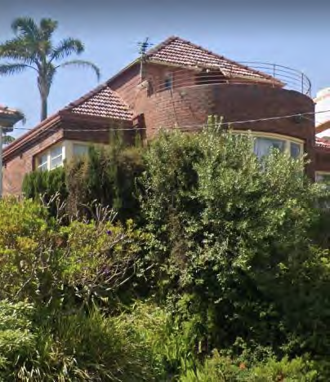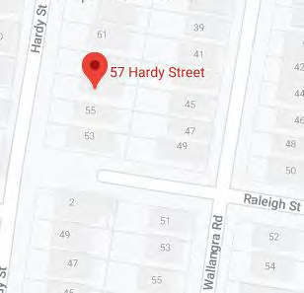  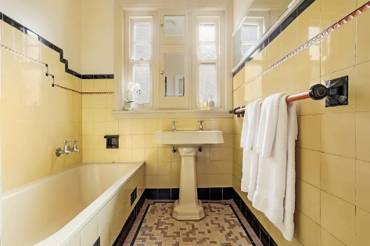  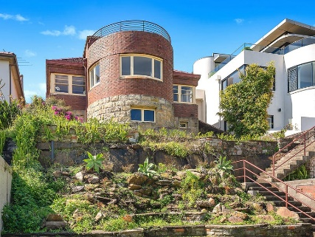  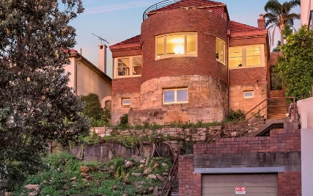
Image year |  | Image by | Google Maps; Domain.com | Image copyright holder

Image caption | 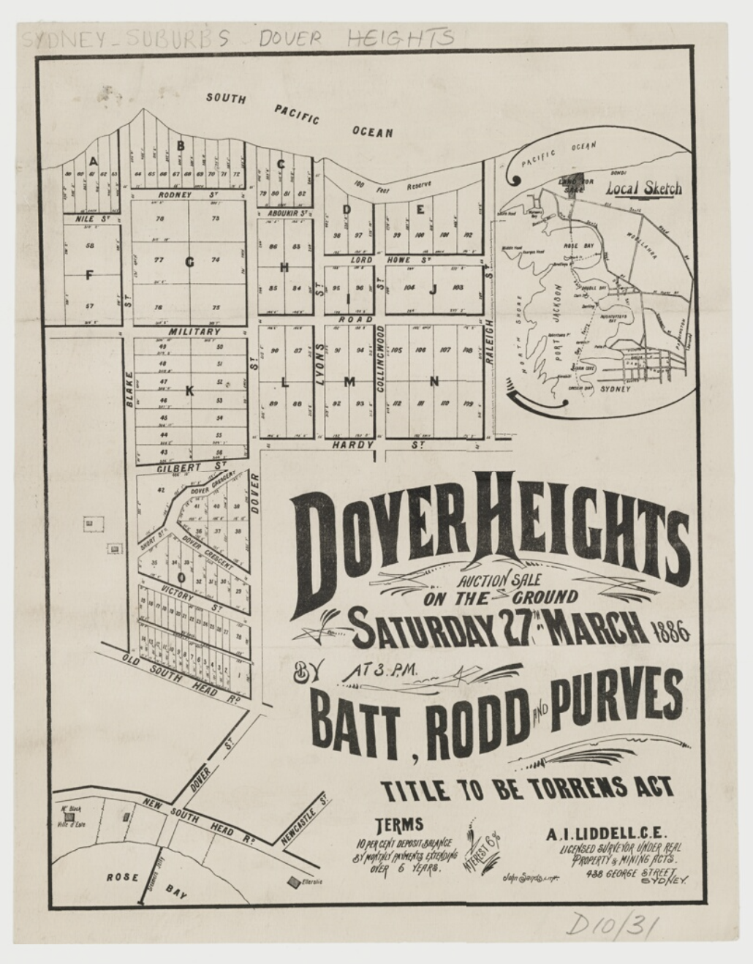
Image year | 1886 | Image by | State Library of New South Wales | Image copyright holder

Image caption | 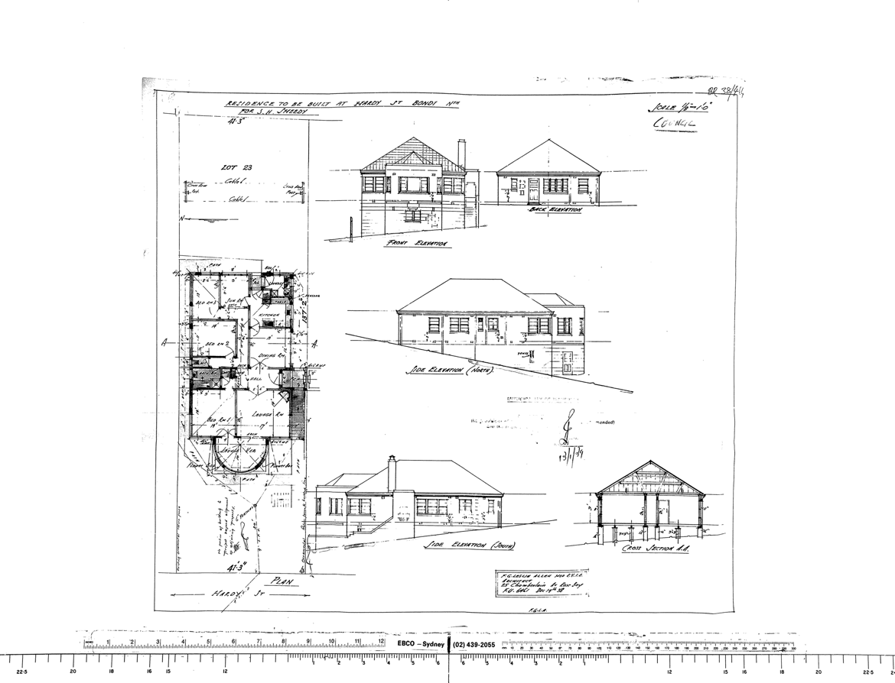
Image year | 1939 | Image by | Waverley Council | Image copyright holder

Image caption | 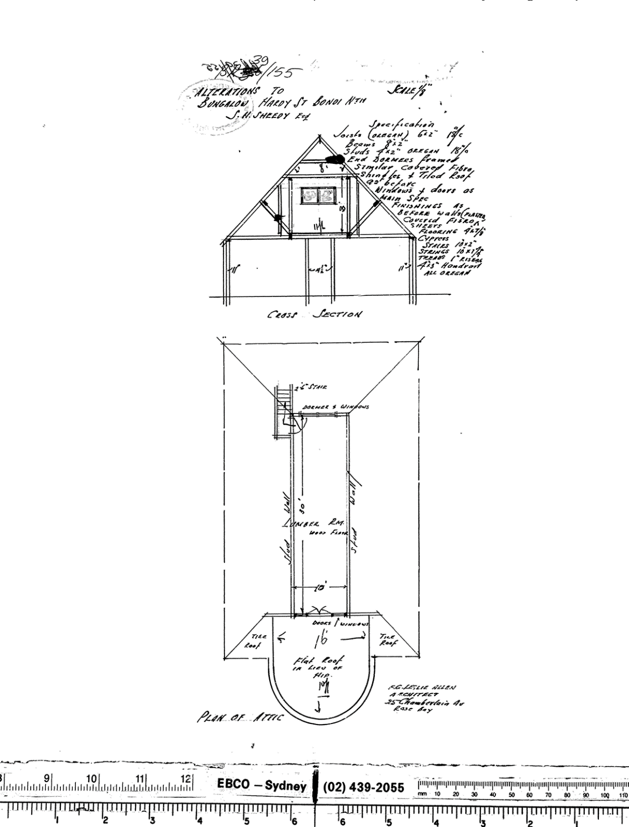
Image year | 1939 | Image by | Waverley Council | Image copyright holder

Image caption | 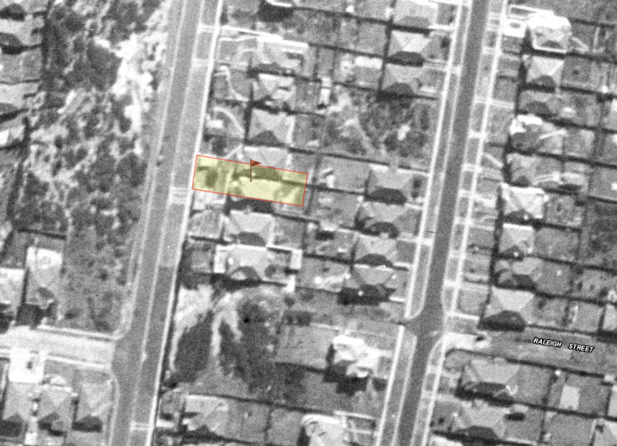
Image year | 1943 | Image by | SIX Maps | Image copyright holder

